**FUCHSIA OPERATING SYSTEM**

***-One operating System for every device.***

Abstract:

Fuchsia is a new operating system announced by google in 2017’s Google i/o. It is a free open source project. Google describes Fuchsia as "a new operating system" designed for " modern phones and modern computers with fast processors, non-trivial amount of RAM with arbitrary peripherals doing open-ended computation. It can run from embedded devices to computers even on dash infotainment for cars, Traffic lights, Digital Watches etc.

As we know every operating system is built on a kernel and also kernel plays important role on the degree of use of a operating system. Fuchsia is built on microkernel know as Zircon, which differs with other Google operating system such as Android and Chrome OS which are built on Linux Kernel. The benefit of Zircon kernel is that it make’s run Fuchsia run on every device I.e. From small phones to pc’s, refrigerators, traffic lights.

“Pink + Purple = Fuchsia” Pink (Apple's first effort at a object-oriented, microkernel based operating system), and Purple (the original iPhone's codename)

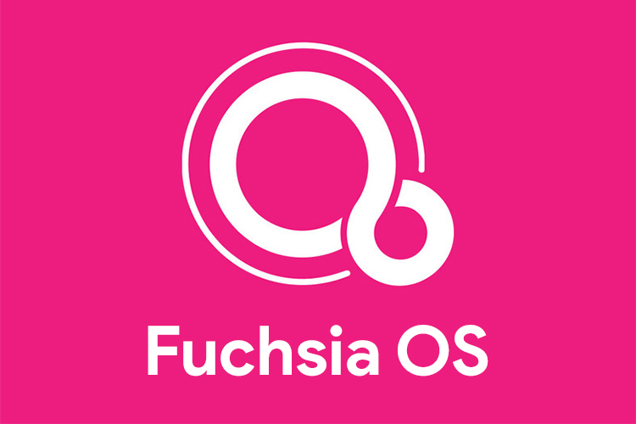

PINK + PURPLE = FUCHSIA

Fuchsia apps and user interface is built upon Flutter Development Kit and Dart programming languages .Fuchsia is written using C , C++ , Dart , Go, Rust. Flutter apps are faster and offers performance at 120 Frames per Second. Android apps can even run on Fuchsia with support of hybrid app development by Flutter.

THE NEED OF FUCHSIA

The problem with Android is it was initially developed for Digital Cameras and built upon on Linux a monolithic Kernel, this where the problem comes is Android Fragmentation I.e. Fragmentation within Android is when a variety of versions of the Android platform, combined with a mixture of hardware result in the inability for some devices to properly run certain application*s and*The Chrome OS is not at its best right now when compared with android.

Conclusion

Fuchsia could become a part of Android and/or Chrome OS without actually replacing them Maybe Fuchsia could come into our lives without much of any disruption and without the vast majority of users even realizing anything had changed. The main advantage of Fuchsia OS is Zircon Kernel.

By

B. Yaswanth kumar ,18501A05C0, CSE-S2

S. Aditya Vardan, 18501A05A5, CSE-S2